Lady Stars of VCE

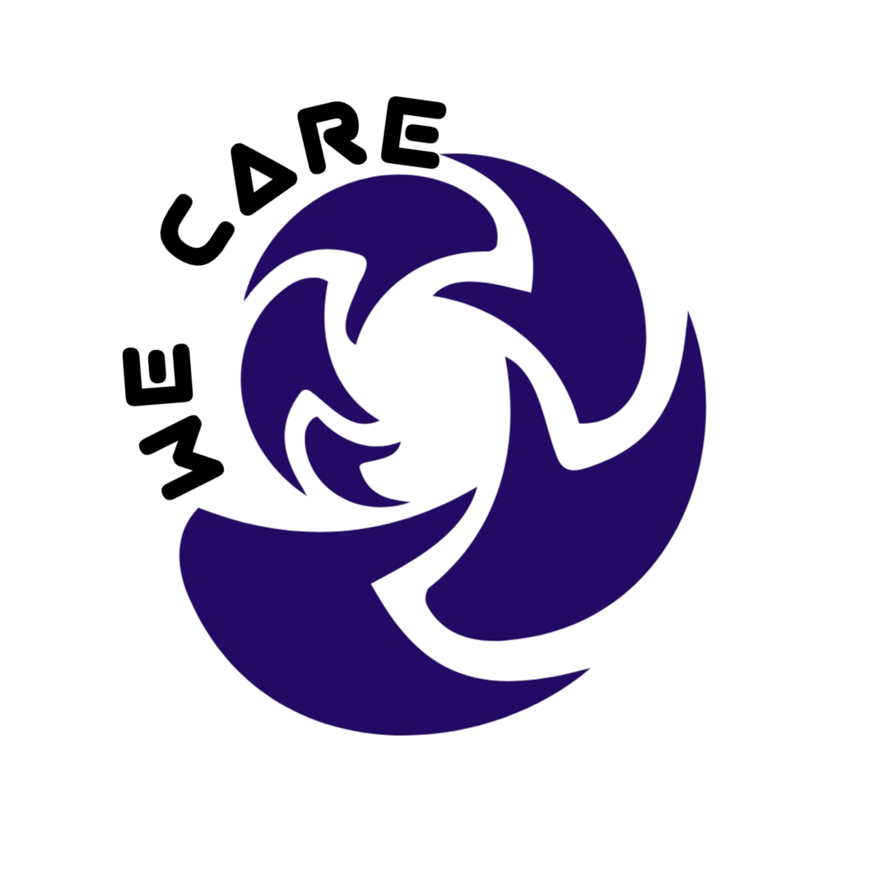

**1. Submission Name:**

**Team Name:** Lady stars of VCE

**Composition:** Maria George(team commander), Amina Afsar, Nair Chandni, Srilakshmi Shastry

**Solution:** An application for virtual employee engagement which also enables social distancing norms within office premises

**2. Short Description:**

We have developed a platform for effective employee engagement which connects all employees. Additionally, it has the feature for maintaining social distancing norms in the office

**3. Long Description:**

**Problem:** As part of the WHO guidelines to prevent the spread of COVID-19, social distancing is the key. Many companies are practicing Work from home effectively and will continue to do so.

In these unprecedented times there is a need for more connectivity amongst employees of an organization and for effective morale boost.

**Background on why employee engagement is necessary:**

Engaged employees are invested in their job and care about the success of their team. It makes sense that they would show up to work.

Engaged employees are firmly committed to their organization's mission, and they're going to arrive every day with the intention make sure it gets done. **In fact, highly engaged workplaces saw**[**41% lower absenteeism**](http://news.gallup.com/reports/199961/7.aspx)

They are beneficial to their families, too. They don't complain about their job to a significant other, have the energy to play with the kids after work, and generally contribute to a positive home atmosphere.

"Techniques don't produce quality products and services, people do. People who care, people who are treated as creatively contributing individuals."

**Engaged Employees lead to:**

* Higher service, quality, and productivity, which leads to…
* Higher customer satisfaction, which leads to…
* Increased sales, which leads to…
* Higher levels of profit, which leads to…
* Higher shareholder returns (i.e., stock price)

**Solution :** As a team, we thought employee engagement is very necessary for an organization in this point of time. To address this challenge we came up with a solution which is an **app named WeCare** – a single platform for enabling virtual employee engagement and also enables the teams for maintaining social distancing norms within office premises.

**Some of the Features of the application we developed:**

1. **As part of employee engagement we have included below features:**
2. Fun Zone
3. Quiz
4. Survey
5. Rewards
6. Home

**Summary of implementation:**

* + To enable the employee engagement, we have customized several features in the app, Under **FUNZONE** we have team events wherein we will post some activity / game which needs to be done by the employees and upload/send their entries to us.

**For eg:** we “Post your selfie on world environmental day” or who completes maximum steps in given time etc. In this way we keep the employees engaged even though all are not face to face.

* + Deployment of quizzes and polls using the IBM kit.
  + Rewards for work done well etc on merit based points system, which will have certain milestones and the person will get rewarded once he touches those milestones. In this way we keep the morale high of the employees.
  + Home page where team can see motivating quotes, which will be updated every day, and Upcoming events or celebrations happening in the department. Along with that this page supports for the team to post news, wishes, achievements, updates from department etc . This will ensure that team is connected even if many are working remotely.

1. **For maintaining social distancing norm:**
2. **Queuing system is enabled for in-house pantry booking** 🡪 for maintaining social distancing, we have queuing system which generates a ticket ID for anyone wanting to visit Pantry, and hence the person can go when his ticket number comes and this avoids overcrowding near pantry space, thereby maintaining social distancing.
3. **Also, as an add-on to this app, we have volunteered to the World Community Grid powered by IBM, which is researching for the fastest solution for Covid-19 crisis**

**Why this app ?** 🡪 The currently available engagement applications are more towards peer reviews, performance reviews, and updates on what is happening in the company etc., this had a challenge of engaging with the team members and connecting with them.

With this App, we can now bring teams together for any employee morale boosting activity, connecting with the colleagues is established, hence we can have employees who are more engaged and happy. In the same App, we have enabled the feature for social distancing in the office.

We are contributing our bit by volunteering in the world community grid in the app

**“To win in the marketplace…you must first win in the workplace. We obsessed with keeping employee engagement front and center.”**

**Open source technology:** [**https://ionicframework.com/docs/react/your-first-app**](https://ionicframework.com/docs/react/your-first-app)

[**https://ionicframework.com/**](https://ionicframework.com/)

**4. Architecture:**

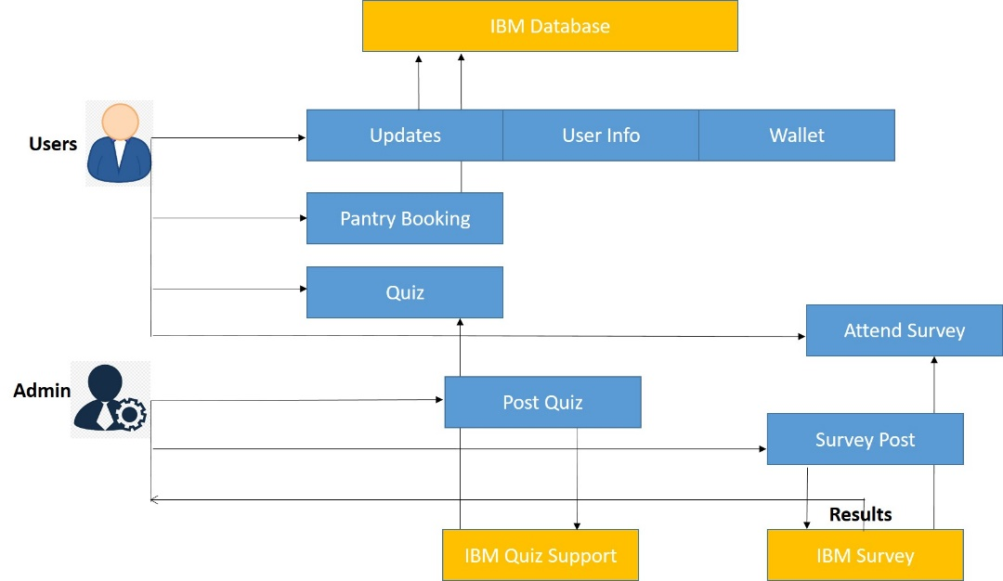

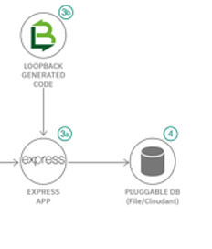

**List of IBM Cloud Services used:**

1. <https://developer.ibm.com/callforcode/get-started/covid-19/remote-education/> - We have used Quiz App under Remote education for developing quiz and survey development.
2. Database for cloud : <https://cloud.ibm.com/catalog/services/databases-for-mongodb>
3. IBM Cloud services for server hosting.

**Getting started**

We have used React-based codebase that runs on the web, iOS, and Android using Ionic Framework. Advantage of this selection is that it can be deployed as a native iOS and Android mobile app using Capacitor, Ionic's official native app runtime.

**Prerequisites**

Make sure that you have an environment with all the below listed applications:

1. Node.js for interacting with the Ionic ecosystem
2. A code editor for... writing code and we have used Visual Studio Code
3. Command-line interface

Also follow the commands for setting up ionic tools using command line interface.

npm install -g @ionic/cli

Then create an empty application that supports tabs by running the following command

ionic start photo-gallery tabs --type=react –capacitor

You can run your code using below command

ionic serve

Then finally build your project and make an apk . We have used Android studio for that.

**Video Link: <https://drive.google.com/file/d/1-3AJTf7V8ZBoJoo3Jdb1ZZWLs_03x69C/view?usp=drivesdk>**

**GitHub Link :** [**https://github.com/MariaGeorge92/WeCare**](https://github.com/MariaGeorge92/WeCare)

**Solution Roadmap:**

Server Application

Mobile Application

Mobile Application

3 June 2020

UI development and testing

UI design for WeCare

Project Design

Ionic environment setup

6 June 2020

API development for Home tab

Server support for Home tab

API development for Book Pantry tab

Server support for Book Pantry tab

6 July 2020

API development for Funzone tab

Server support Funzone tab

Profile tab support and final testing

Profile tab support and final testing

31 July 2020

Hosting in IBM Cloud

**Mobile Application Images :**

